My favourite way of travelling
We can travel everywhere,
By road, by sea, by rail and by air.
But the most exiting way, as you guess,
For me - on foot, I can you confess.
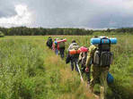
Hiking and camping are so cheap
They help us our health to keep.
You needn’t buy tickets and pay for rent
It’s so romantic to live in the tent.
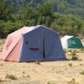
Popugayev Andrei 8a

