Витамины по-английски

You are going to read about vitamins. Before you read, mark the statements true (T) or false (F). Then read the text and check your answers.

- Vitamins make people healthy.

- We get vitamins doing sports.

- People don't need vitamin С.

- If you want to be healthy you should eat less fruit and vegetables.

- There are about ten vitamins extremely necessary for the people.

People need vitamins to stay healthy. "Vita" means life in Latin. People get vitamins from the food they eat. There are a lot of vitamins in fruit and vegetables. But you can hardly find any useful vitamins in Coke, chips and other fast food. Each vitamin is responsible for different things in the human body. There are about ten major vitamins. They are usually named by a letter of the alphabet (А, В, C, D, etc.)
- Vitamin A is in green and yellow vegetables, milk and eggs. It's necessary for seeing in the dark.
- Vitamin B1 is in meat, porridge and bread. B1 is responsible for the nervous system. Lack of this vitamin leads to serious illnesses and even death.
- Vitamin С is in every fruit and vegetable. You can find this vitamin in black currants, strawberries, oranges and grapefruits, onions, cabbages and green peppers. Vitamin С is important for building bones and teeth. It helps to prevent colds.
- Vitamin D is in eggs. People can also get it from sunlight. It makes our bones strong.
- Vitamin E is necessary for skin and body. It's in the wheat and nuts.
- Vitamins B₆ and К are necessary for human blood. You can find B₆ in beans and milk; К — in potatoes, tomatoes and carrots.
- Vitamins make people healthy, optimistic and strong.
Remember:
I eat to live, but I don't live to eat. Choose healthy food.

Read the text. Say if you have a sweet tooth like the British.
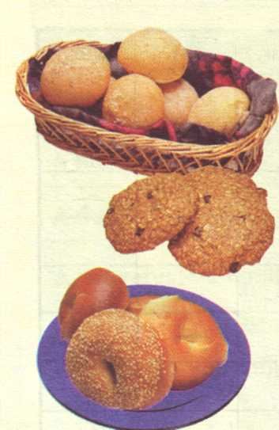
Sweet tooth
The British have a sweet tooth. That means they like eating sweet things like puddings and pies, jams, biscuits and buns, cakes and rolls.
For the British, any time is eat-a-sweet time: tea-break at work, break at school, watching TV at home, on a car journey, in the cinema or theatre. During holidays like Christmas and Easter, and on special days like Mother's Day and Valentine's Day they eat even more sweet things.
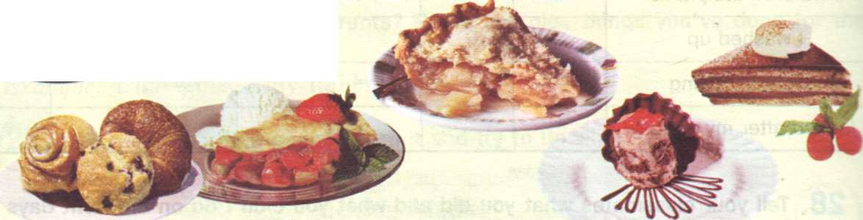
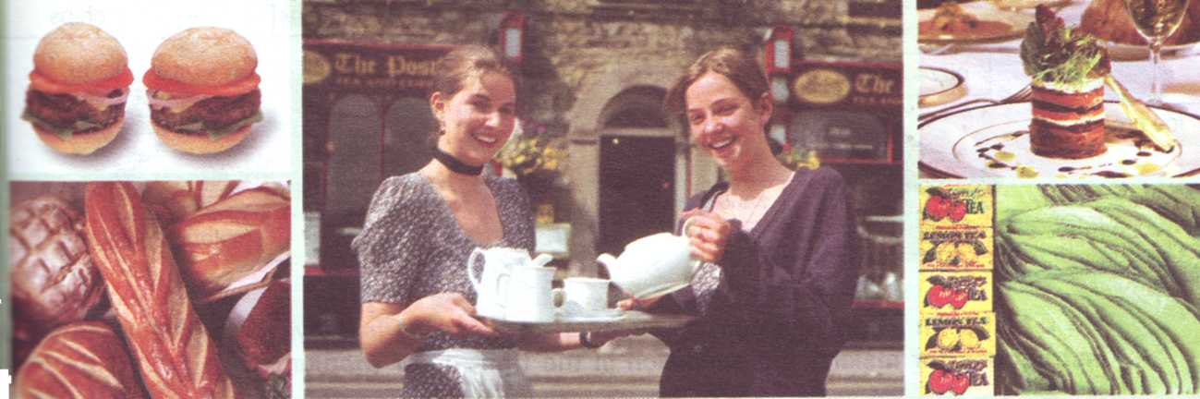
Read the text. Say if you share English tastes.

English Sandwiches and English Tea

A lot of people in England eat sandwiches for their lunch. There are a lot of sandwich shops in London. You can buy all sorts of sandwiches in these shops. You can get meat sandwiches, or salad sandwiches, or meat-and-salad sandwiches. And you can get cheese, egg or fish sandwiches. You can even buy fruit sandwiches. Each sandwich has two thin slices of bread. You put butter and meat between the two slices. Lots of foreigners don't like English sandwiches. They like the kind of sandwich we call a roll. Some foreigners don't like English tea, either. English tea is very strong. We make it in a teapot (чайник). The English drink a lot of tea.

Do you know what these things are made from?
Example: Cheese is made from milk.

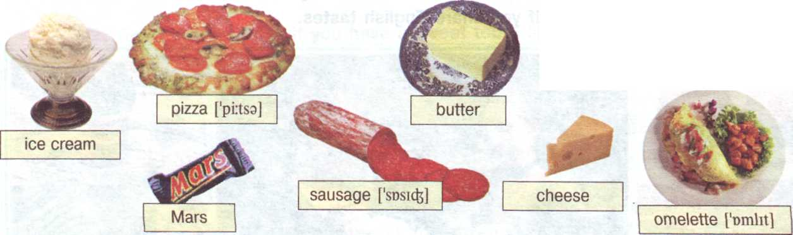

Eggs and Spring Onion
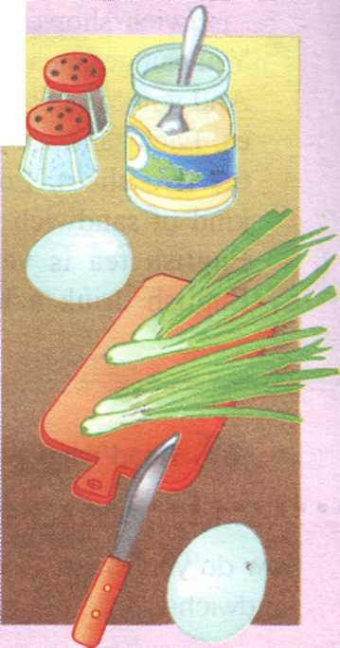
- Boiled [boild] (вареные) eggs
- Tablespoons of mayonnaise [,mei9'neiz]
- Spring onions, salt (соль) and pepper (перец)
- Chop (измельчите) the eggs into small pieces.
- Wash the spring onions. Cut off the green part.
- Chop the spring onions. Add to the eggs.
- Put the chopped eggs into a bowl (миска).
- Add the mayonnaise. Mix the eggs, spring onions and mayonnaise together.
- Peel (очистите) the eggs very carefully.
- Wash them under cold water and dry them well.
- Put the rilling (начинка) on the sliced bread.
- Add some salt (соль) and pepper (перец).

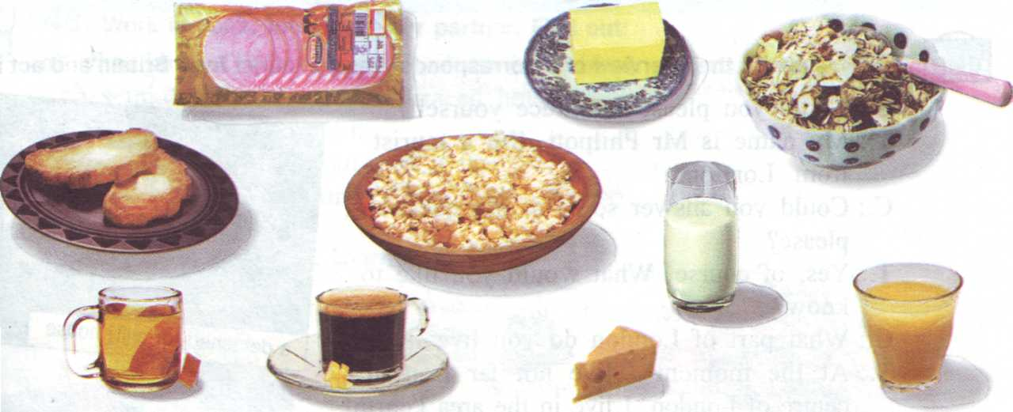
3 Choose which food you think it is better to have for breakfast and say why:

