**Sample tests**

**Test 1 UNITS 1-3**

**1 Match the words with the phonetic script.**

|  |  |
| --- | --- |
| 1 | a) school |
| 2 ['kwestfnz] | b) teacher |
| 3 | c) in front of |
| 4 | d) whose |
| 5 ['ti:tf3] | e) chat |
| 6 [hu:z] | f) girl |
| 7 | g) questions |
| 8 [sku:l] | h) America |

*Score ____/8*

2 Listen to the conversation and find the photo

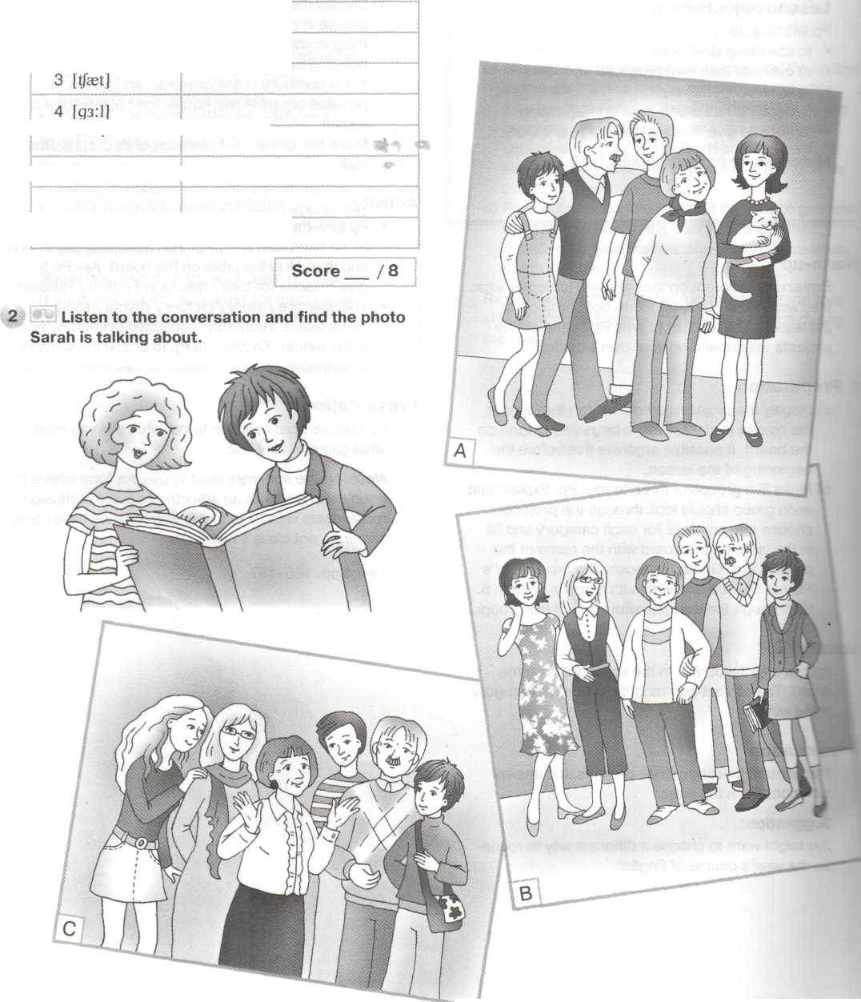 Sarah is talking about.

*Score ____/8*

**3 Look at the pictures read the texts and write the girls' names.**

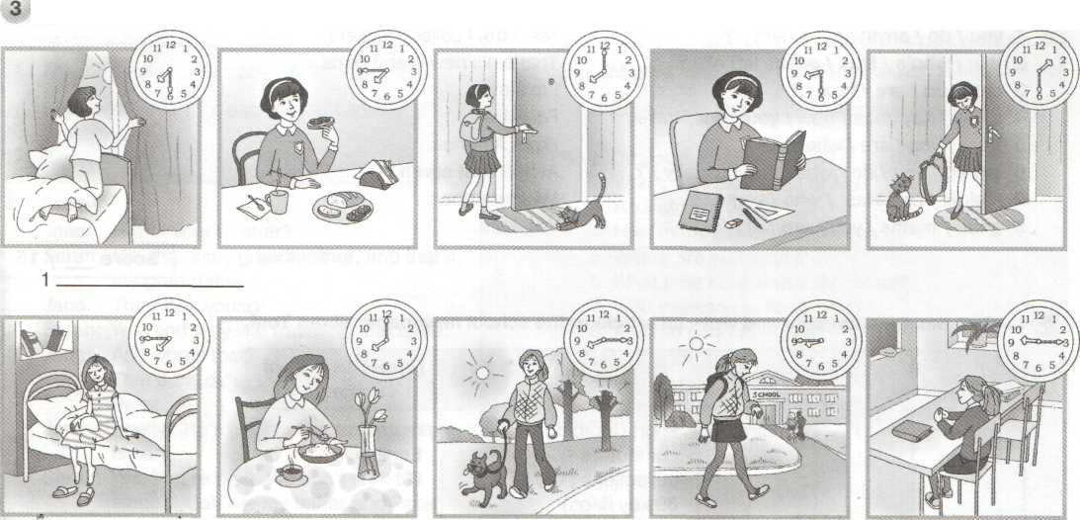

2______________

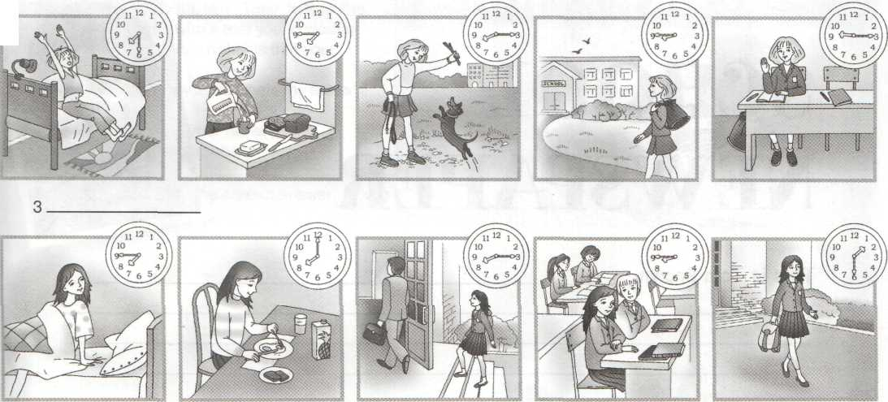

4__________________

**Sasha** gets up at quarter to eight. She has breakfast at eight o'clock and walks her dog at quarter past eight. She goes to school at quarter to nine. Her lessons start at quarter past nine.

**Masha** gets up at half past seven. She has breakfast at quarter to eight. She goes to school at eight o'clock. Her lessons start at half past eight. She comes home from school at half past one.

**Dasha** gets up at quarter to eight. She has breakfast at eight o'clock and goes to school at quarter past eight. Her lessons start at quarter to nine. She comes home from school at half past one.

**Natasha** gets up at half past seven. She has breakfast at quarter to eight and walks her dog at quarter past eight. She goes to school at quarter to nine. Her lessons start at quarter past nine.

***Score ___ / 8***

**4 Write questions to the answers.**

1. you / do / anything / collect / ? Yes, I do. I collect stickers.
2. that / who's / Max / on the left of / ? That’s his new friend Dima.
3. old / you / are / how / ? I’m eleven.
4. many / key rings / how / you / got / have / ? Forty five.
5. from / you / are / where / ? From America.
6. get up / you / do / what time / usually / ? At half past seven.
7. makes / breakfast / who / your / ? My mum does.
8. good / maths / you / are / at / ? Yes, I am.

***Score ___/ 16***

**5 Look at the questionnaire and write an article to the school newspaper about Tom.**

|  |  |  |  |  |
| --- | --- | --- | --- | --- |
| **Name** | **Age** | **Country** | **Hobbies** | **Favourite school subjects** |
| Tom Brown | 11 | Australia | sport (football)  computers collections (120 CDs,  89 key rings) | Maths  English  IT |

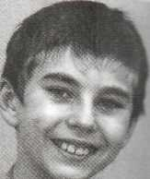

**SCHOOl NEWSPAPER**

This is Tom Brown. _____________________________________________________________________________________________________________________________________________________________________________________________________________________________________________________________________

***Score___/ 10***

***Total ___/ 50***

**Test 2 UNITS 4-5**

4a Read the recipe and write a shopping list for it.

1. You are at the zoo. Listen to the zoo guide   
   and fill in the observation sheet for your quiz.

RECIPE

Mushroom omelette

Makes 2 servings Cooking time — 15 minutes You need

* 4 mushrooms
* 4 eggs
* 2 tablespoons of milk
* 1 teaspoon of butter
* salt if needed

Take the mushrooms and cut them into small

pieces. Add the eggs and butter. Mix with

2 tablespoons of milk. Add some salt.

**Observation sheet**

**Name:_______________________________**

**Colour:________________________________**

**Food:_________________________________**

**Has:___________________________________**

**Does:__________________________________**

***Score___/ 5***

**2 Write the words in each group.**

***Score___/ 5***

|  |  |
| --- | --- |
| apple | butter |
|  |  |

Shopping list

carrot chicken cucumber peas rice salmon tomato bread chocolate salt pear mushrooms

*___________________________________*

***Score___/ 6 ____________________***

3 Write which food from the list Max bought / 4b Read the recipe again and write

didn’t buy. T (true) or F (false). _______

Example: He bought some tomatoes. He didn’t buy 1. You don’t need any sugar.

any water. 2. You mix the eggs with milk first.

3. You can add some salt if needed.

4. You cook the omelette for 10 minutes.

Shopping list

1. 1 kilo of tomatoes
2. 2 bottles of water
3. 1 bar of chocolate
4. 1 loaf of bread
5. 2 kilos of cucumbers
6. 1 kilo of rice
7. 4 eggs
8. 1 carton of juice
9. 2 carrots

10. 1 packet of crisps

**Score___/ 4**

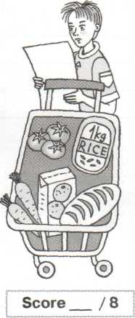

***Score___/ 8***

**5 Write five true sentences about the animals.**

|  |  |  |  |  |  |
| --- | --- | --- | --- | --- | --- |
| The | elephant  dolphin  frog  seal  crocodile  giraffe | uses its | long neck  sharp teeth  long tongue  blowhole  flippers  trunk | to | breathe  catch flies  get food  catch its prey  walk and swim |

***Example:*** *The giraffe uses its long neck to get food.*

1. **__________________________________________________________**
2. **__________________________________________________________**
3. **__________________________________________________________**
4. **__________________________________________________________**
5. **__________________________________________________________**

***Score___/ 10***

**6 Play 'At the Lost and Found'.**

**Pupil A.** You left your shopping bag with some food on a bus. Ask at the Lost and

Found Office for your bag. Answer questions about your bag.

**Pupil B.** You work at the Lost and Found Office.

Pupil A left a shopping bag with food on a bus. Help him / her to find the bag. Ask

Pupil A questions about the bag to identify it.

***Score ___/12***

***Total___/50***

**Test 3 UNITS 6-8**

**1 Listen to what children did at the weekend 2 Put the verbs into the right columns.**

**and match the pictures with the children's names.** discovered, killed, lived, hunted, wanted, fished,

**There is one extra picture.** learned, collected, liked, used

|  |  |  |
| --- | --- | --- |
| **[ t ]** | **[ d ]** | **[ id ]** |
|  |  |  |

**Sarah**

**Nick**

**Tracy**

**Margaret**

**Stephen**

***Score ____/5***

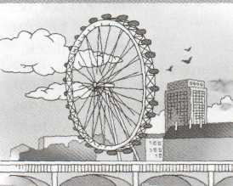

**3 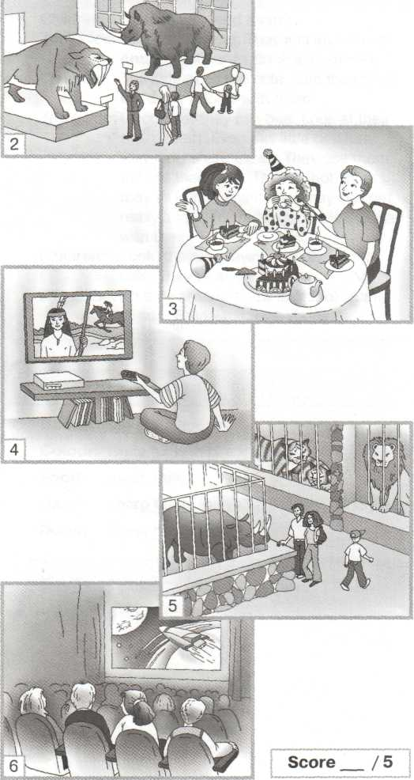Read and write T (true) or F (false).**

Archaeologists discovered a lot of interesting things about ancient Egyptians:

They wore very simple clothes. Little kids didn't wear clothes at all. Egyptian girls got married at the age of twelve. Women in ancient Egypt used a lot of make­up (косметика). They coloured their eyes, lips, cheeks. Men coloured their eyes too. Many families in ancient Egypt had pets. Egyptians built pyramids for their dead kings. They put beds, tables, chairs end even toilets their. Tut (Tutankhamun) was a famous Egyptian king. Archaeologists discovered his tomb (могила) in 1923.

1 Children in ancient Egypt wore very

simple clothes.

1. Men in ancient Egypt used make-up.
2. Egyptian girls got married at the age

of twenty.

4 Egyptians built a lot of pyramids and

lived there.

5 Tutankhamun is a name of a king of Egypt.

***Score ____/10***

**4 Write questions for the answers.**

**1** Yes, they did. The Egyptians built pyramids.

Did____________________________________

**2**The Native Americans lived in teepees.

Where_________________________________

**3** Sabre-toothed tigers lived many years ago.  
 When___________________________________

1. Yes, they were. The Native Americans were  
    hunters and fishermen.

Were___________________________________

1. Alexander the Great liked horses very much.  
    Who_____________________________________

***Score ____/5***

**5 Correct the mistakes.**

1. The bigest supermarket is opposite my house.
2. I live in the noisyest street.
3. The Sydney Opera House is one of the famous buildings in the world.
4. The Petronas Twin Towers are tallest twin towers in the world.
5. Red Square is most popular tourist place in Moscow.

***Score ____/5***

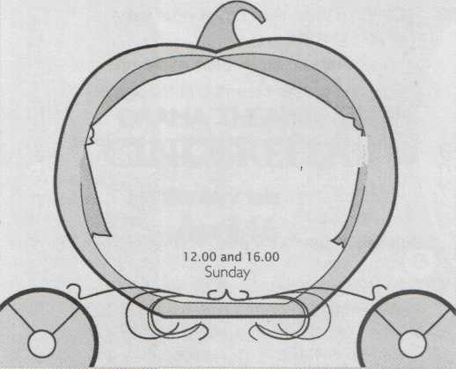**6 Choose a play you would like to see. Write a note to your friend and invite**

DRAMA THEATRE

CINDERELLA

the fairy tale

April, 16

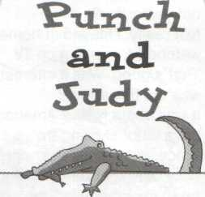 **Punnet theatre**

**March, 20**

**Saturday**

**14.00and 18.00**

Let’s_____________________________________________________

It’s a_____________________________________________________

It’s on ___________________________________________________

It starts___________________________________________________

***Score ____/10***

**7 Tell your foreign friend about the most popular places in your city / village.**

**Invite him / her to visit them.**

***Score ___/10***

***Total___/50***

**Test 4 UNITS 9-10**

**1 You are in the Central Space Centre on the Earth. A space ship is in danger on a strange planet. You are going to send a rescue ship (корабль-спасатель). Listen to the last captain's report and find the planet.**

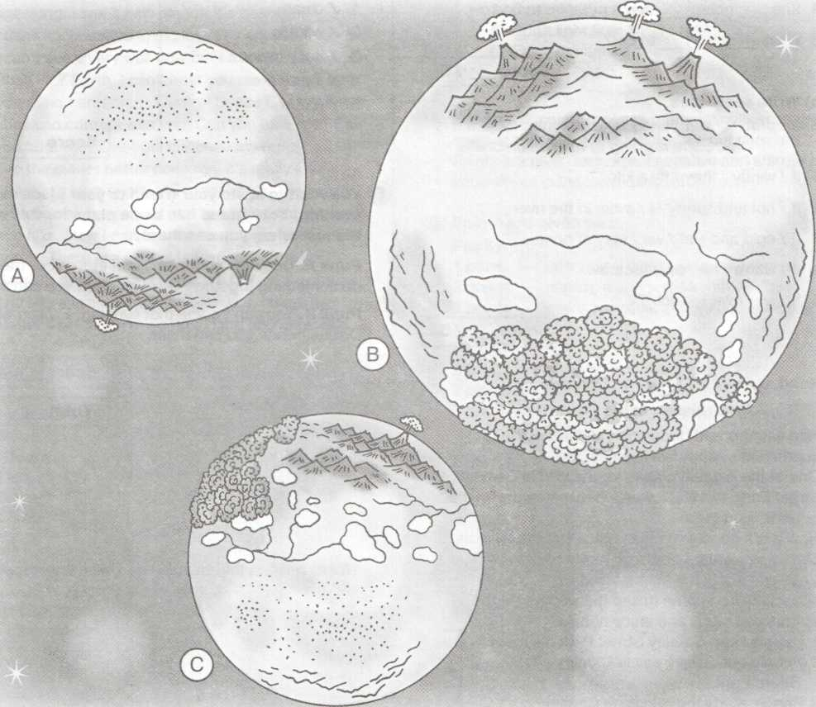

***Score ___/5***

**2 Write the weather words.**

|  |  |  |  |  |  |  |
| --- | --- | --- | --- | --- | --- | --- |
| **1** | **2** | **3** | **4** | **5** | **6** | **7** |
| http://thetattoo.ru/tattoo-risunki-eskizu/solnce/tatyirovka-solnce8.jpg | C:\Program Files\Microsoft Office\MEDIA\CAGCAT10\j0293828.wmf | http://img.cliparto.com/pic/xl/180008/3011274-autumn-maple-tree-on-wind.jpg | **-30 °С** | **6 °С** | **15°C** | **27 °C** |
|  |  |  |  |  |  |  |

sunny _________ ________ _________ cool _________ _________

***Score ___/10***

**3 a) Complete the sentences with be *going to. 5* Visitors of Camley Street Park need to**

***Example:***When *is* he *going to* come? **know what they can do and what they can't do**

1. When are you _____to get up tomorrow? **in the Park.**
2. I____ going _____get up at seven. **Write five rules on how to keep Camley Street**
3. What ______ you ______ ______ buy? **Park.**
4. She ______ going _____ see a new film tomorrow.

**Visitors Information**

1. clean
2. wildlife
3. cut/trees
4. light/fires
5. nature
6. What ______ they ______ to eat?

***Score ___/5***

**b) Write sentences.**

***Example:*** *If / wet / she / take an umbrella.—*

*If it is wet, she is going to take an umbrella.*

1. If/windy/they/fly a kite. ***Score ___/10***
2. If / hot and sunny / I / swim in the river.
3. If / cold and wet/we / stay at home. **6** **You want to invite your friend to your place for an**
4. If/warm / he/play football. **evening. Your friend has some plans for this date.**
5. If / wet / we / watch TV. **Discuss when you can meet.**

***Score ___/5***

**4 Read and write T (true) or F (false).**

**Nature in the City**

Wild animals and birds don't just live in the **Pupil A.** Describe your plans and invite your friend to

countryside. Many live in cities, too. do something together. Discuss when you can meet.

One of the biggest places for the wild is Camley **Pupil B.** You can't come that evening. Explain why.

Street Park. In 1983 it was a dirty place, no animals Discuss when you can meet.

or birds lived there. ***Score ___/10***

Now it is a good and clean place for wild animals, ***Total ____/50***

birds and plants. People go to the park to plant

trees and study the animals and birds. Many

schoolchildren come to see the wildlife. All the

visitors can study and enjoy nature.

1. People keep Camley Street Park clean.
2. People cut down trees in Camley

Street Park.

3 People study the wildlife in Camley

Street Park.

4 Children come to Camley Street Park

to look at the animals, birds and plants.

5 Camley Street Park is dirty.

***Score ___/5***.