**Новогодний паровозик**

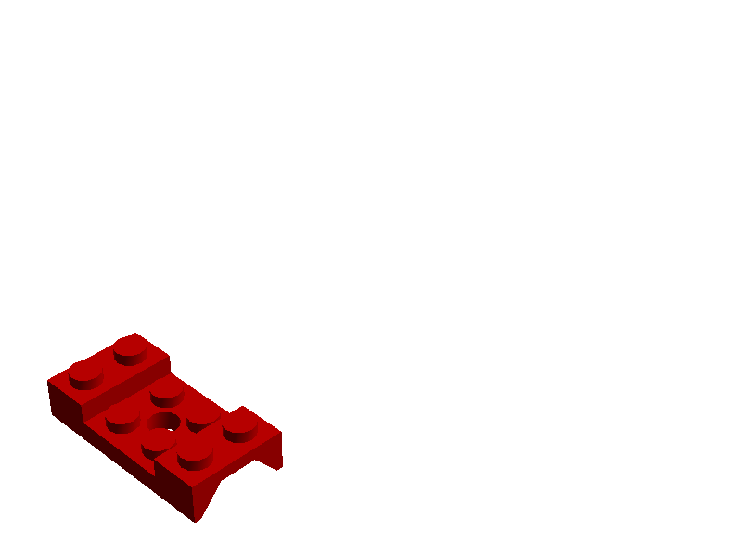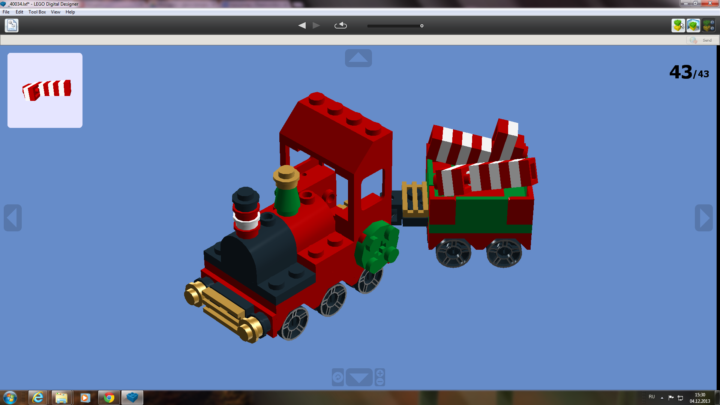

4. PLATE 1X1 ROUND

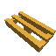

5. RADIATOR GRILLE 1X2

3. PLATE 1X2 WITH SLIDE

2. ANGLE PLATE 1X2/1X4

1. MUDGUARD 2X4 W.HOLE

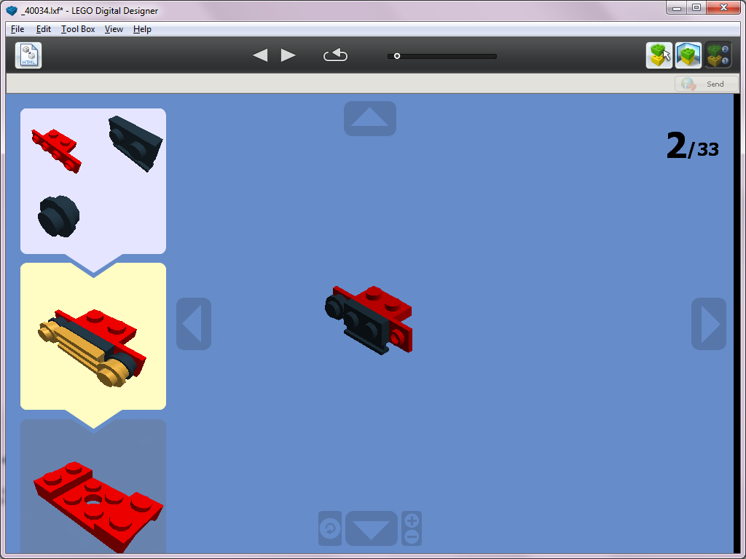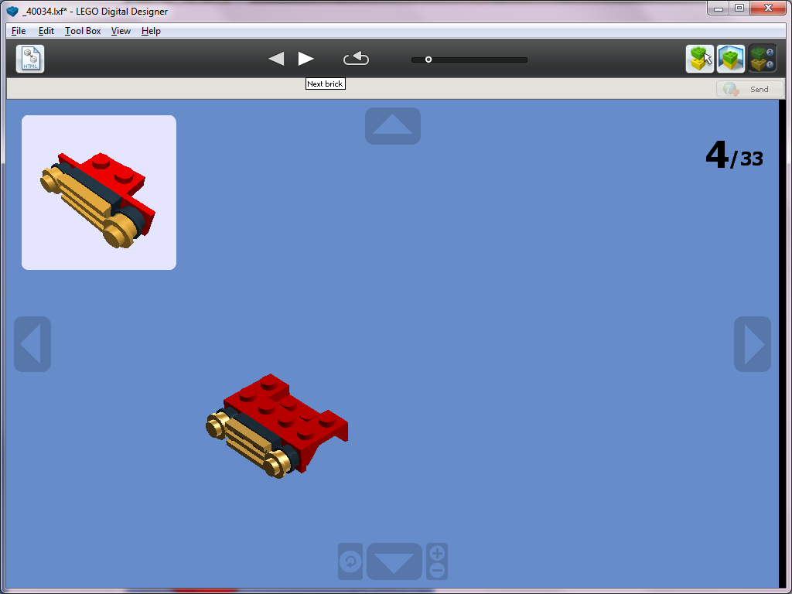

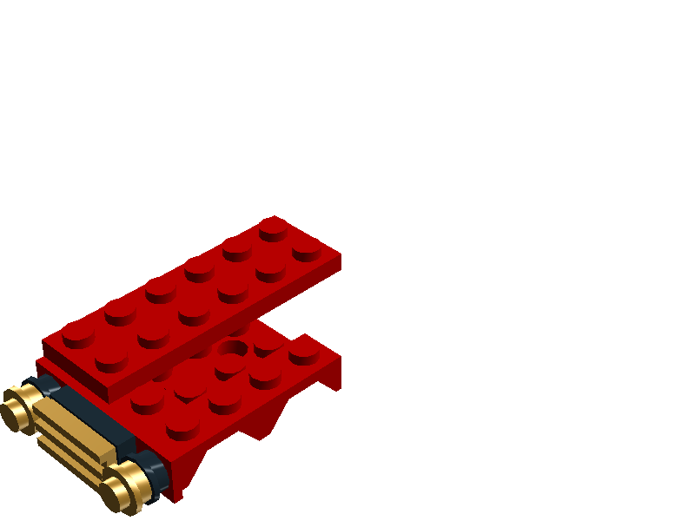

6. PLATE 2X6

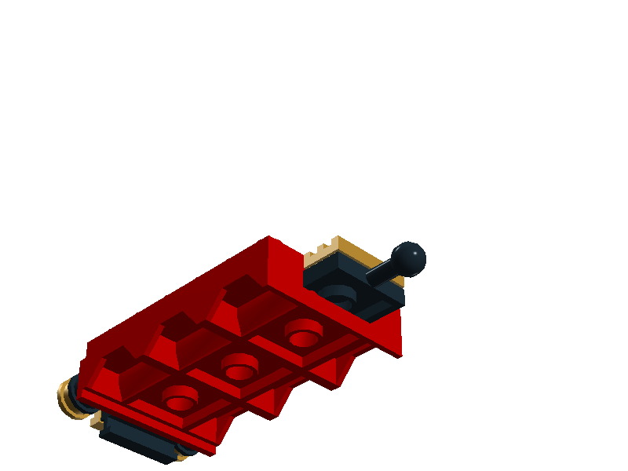

7. PLATE 2X2 W.BALL

8. RADIATOR GRILLE 1X2

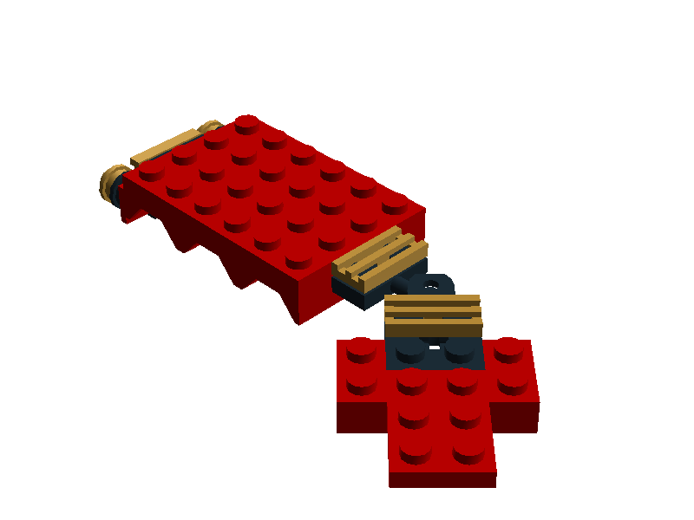

10. PLATE 2X3

9. PLATE 2X2 W BALL SOCKET

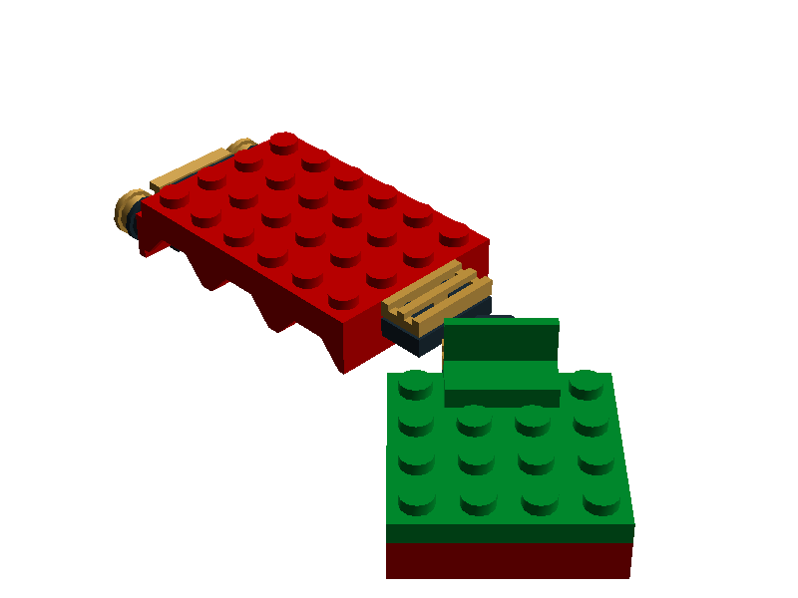

12. WALL ELEMENT 1X2X1

11. PLATE 2X4

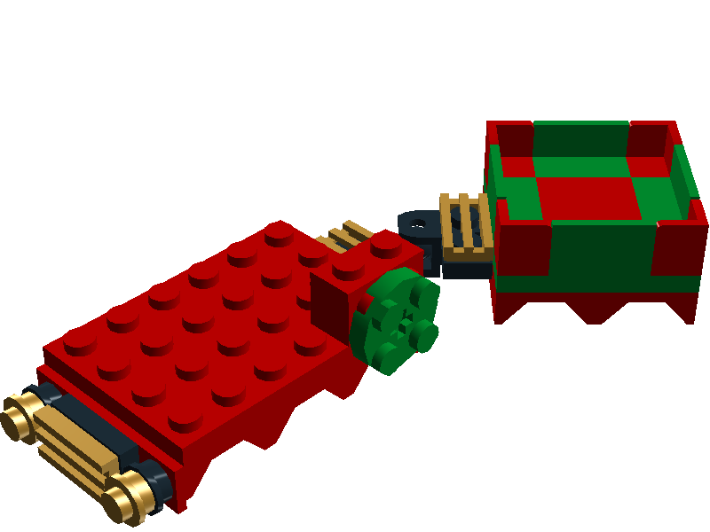

16. BRICK 1X2 W.FOUR KNOBS

15. PLATE 2X2 ROUND

14. FLAT TILE 2X2

13. WALL CORNER 1X2X1

****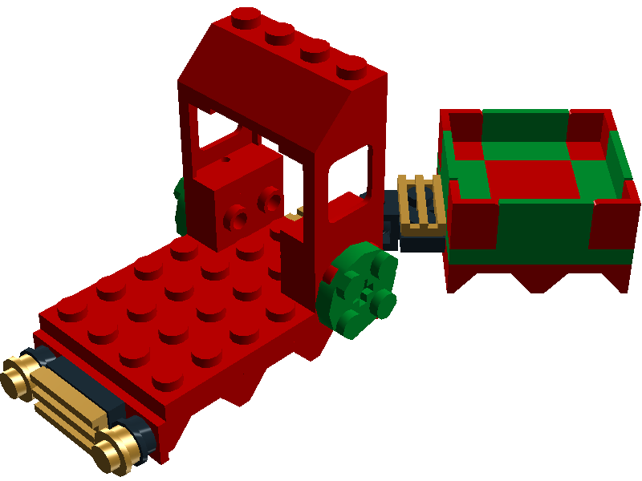

18. ROOF TALE 2X4/45

17. WALL ELEMENT 1X2X2 WINDOW

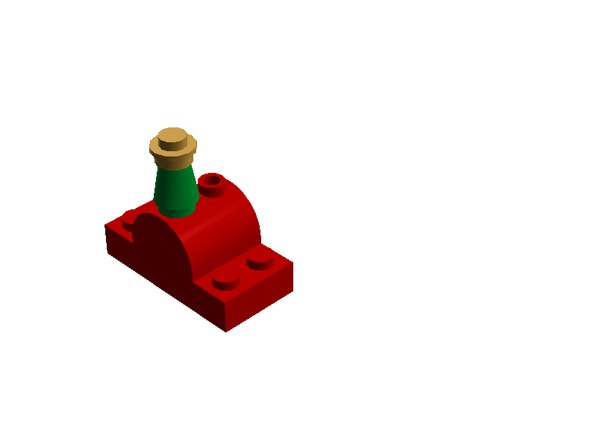

20. PLATE 1X1 ROUND

22. NOSE CONE SMALL 1X1

21. BRICK 2X2 W.BOW AND KNOBS

19. PLATE 2X4

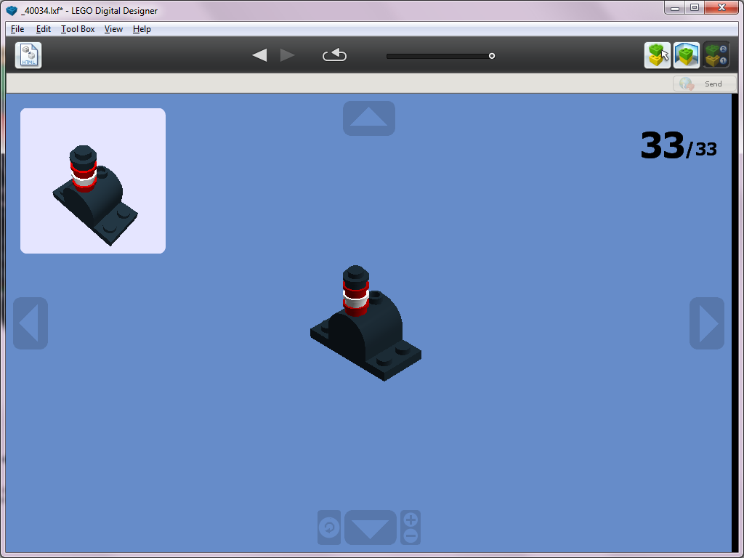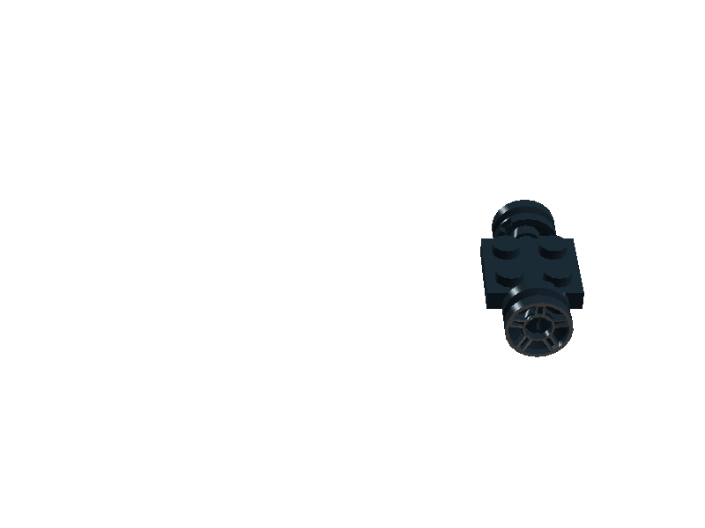

25. PLATE 2X2

26. BRICK 2X2 W.BOW AND KNOBS

24. BEARING ELEMENT 2X2, DOUBLE

23. RIM NARROW

W.HOLE 🛇11.2X6.2



27. PLATE 2X4

