Test 1.1 Choose the right item. See a map of Russia if necessary.
THE REPUBLIC OF THE RUSSIAN FEDERATION

1. The official name of our homeland is…
- Russia
- the Russian Federation
- the Republic of the Russian Federation
2. Russia is washed by 12 seas of three oceans: …
- the Pacific, the Arctic and the Atlantic
- the Pacific, the Arctic, the Atlantic and the Indian
- the Pacific, the Arctic and the Indian
3. The Caucasus Mountains are…
- in the East of the country
- between the Black and the Caspian Seas
- along the border with Mongolia
4. The largest mountain chain, … , separates Europe from Asia.
- the Urals
- the Altai Mountains
- the Caucasus
5. The river Ob is situated…
- on the East European Plain
- on the West Siberian Lowland
- in East Siberia
6. The five ancient Russian towns which are known as Zolotoe Koltso include Rostov Velikiy, Suzdal, Vladimir, Zvenigorod and …
- Tver
- Smolensk
- Yaroslavl
Test 1.2 Choose the right item. See a map of Russia if necessary.
THE REPUBLIC OF THE RUSSIAN FEDERATION

1. The official name of our country is…
- the Russian Federation
- the Republic of the Russian Federation
- Russia
2. Russia stretches from …in the West to the Pacific Ocean in the East.
- the Baltic Sea
- the Caspian Sea
- the Black Sea
3. The Altai Mountains are…
- between the Black and the Caspian Seas
- in the North of the country
- along the border with Mongolia
4. … are the natural divide between Europe and Asia.
- The Altai Mountains
- The Ural Mountains
- The Caucasus Mountains
5. The river Volga is situated…
- on the East European Plain
- on the West Siberian Lowland
- in East Siberia
6. The five ancient Russian towns which are known as Zolotoe Koltso include Rostov Velikiy, Yaroslavl, Vladimir, Zvenigorod and …
- Suzdal
- Smolensk
- Tver
Test 1.3 Choose the right item. See a map of Russia if necessary.
THE REPUBLIC OF THE RUSSIAN FEDERATION

1. The official name of our country is…
- the Russian Federation
- the Republic of the Russian Federation
- Russia
2. Russia is washed by the Bering Sea, the Sea of Okhotsk and … in the East
- the Sea of Japan
- the Baltic Sea
- the Black Sea
3. The Caucasus Mountains are…
- in the centre of Russia
- in the North of the country
- in the South of Russia
4. … separate Europe from Asia.
- The Altai Mountains
- The Ural Mountains
- The Caucasus
5. The longest river in Europe is …
- the Volga
- the Don
- the Neva
6. The original name of the city on the Neva banks was…
- Petrograd
- St Petersburg
- Leningrad

Ключи к тестам
1.1.
1. – c
2. – a
3. – b
4. – a
5. – b
6. – c

1.2.
1. – b
2. – a
3. – c
4. – b
5. – a
6. – a

1.3.
1. – b
2. – a
3. – c
4. – b
5. – a
6. – b

The Flag of the Russian Federation

The Russian flag is sometimes called the IMPERIAL FLAG. It consists of three equal stripes of white, blue and red. The first flag of this design appeared more than 300 years ago. Peter the Great adapted the flag from the National flag of the Netherlands. Later a black two-headed eagle on a golden background was added to the flag of Russia. The flag existed until the revolution in 1917. In the nineties, with the democratic changes, the three-colour flag was restored again. On 21 August 1991, the flag was officially adopted by the Russian President and the Russian Parliament. In Russia the colours of the current flag symbolize:
- white — frankness and generosity;
- blue — honesty and wisdom;
- red — courage and love.

The Emblem of the Russian Federation

The Russian National Emblem is the golden DOUBLE-HEADED EAGLE with a horseman (St George) on a shield on the eagle's breast with a red background. Above the two heads of the eagle, there is an historical crown.
The first emblem of the double-headed eagle was introduced in 1480, by Prince Ivan III. It was at the time of the establishment of the Russian state system. It symbolized the supreme power and sovereignty of the state.
Since then, the double-headed eagle is the main part of the emblem of our country. But now the crown is a symbol of the sovereignty both of the Russian Federation (as a whole) and of its parts (subjects of the Federation.
Карточка с установками на ролевую игру

Role play the situation.
Imagine that you are a foreigner. Your name is Mark MacWizard; you are a student from Tunbridge Wells, England. You began learning Russian two years ago and took an interest in this country. Recently you have come to Russia to see it with your own eyes. You are very interested in everything connected with the country.
Two days ago you visited Moscow, went sightseeing there and took some pictures of its places of interest.
Now you are visiting students of the ninth form in town of Balakovo. You are taking part in their talk about Russia.
Your communicative intentions:
- introduce yourself;
- ask about traditionally Russian souvenirs and gifts;
- ask about one of the famous Russian people you can’t recognize (their portraits are on the blackboard);
- say that you have learnt a lot of new things about outstanding Russian people during your current visit;
- say a few words about staying in Moscow, tell the students that the city is remarkable for its monuments, show these photos and ask students to help you making up captions for them;
- answer some student’s questions;
- thank the students for their hospitality.

Картинки и заголовки
к текстам для чтения (задание 6)

Headlines: Russian Tea Drinking (c), Russian Souvenirs (b), Traditional Menu (a)

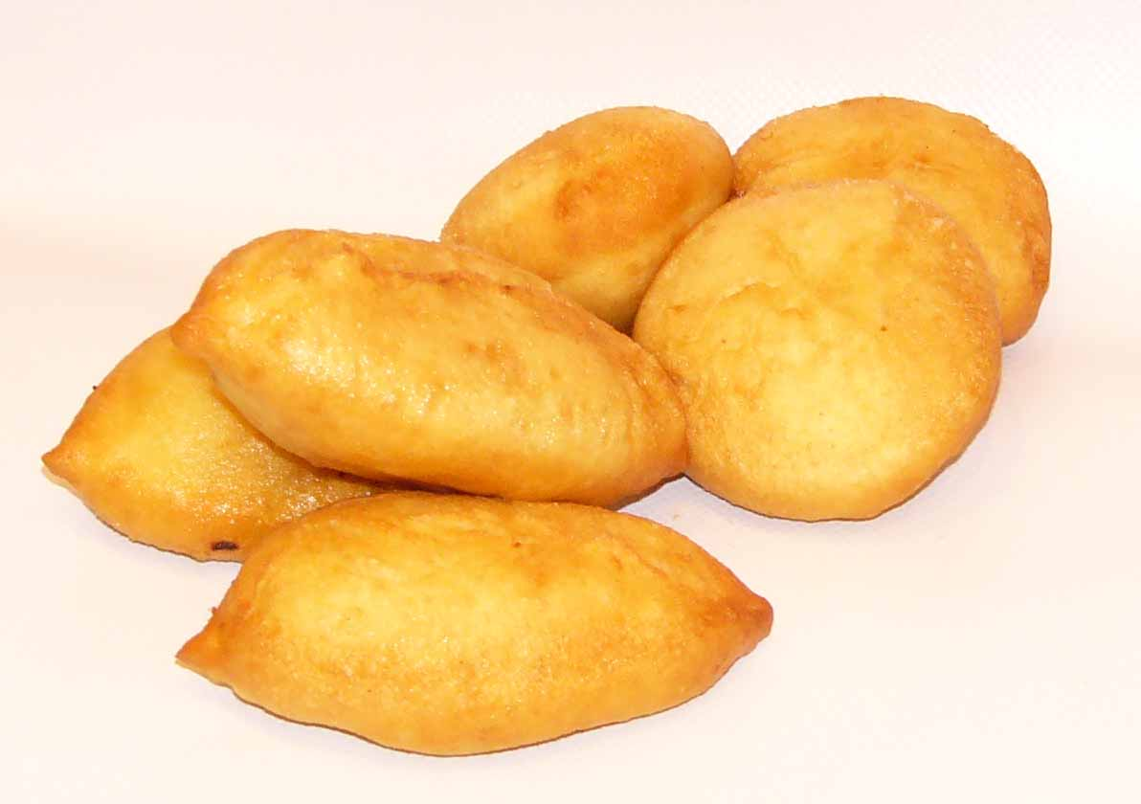
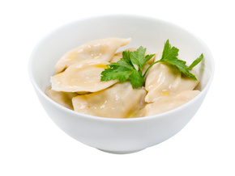

a)

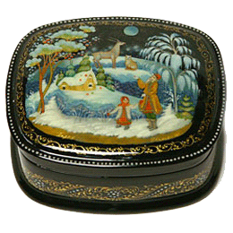
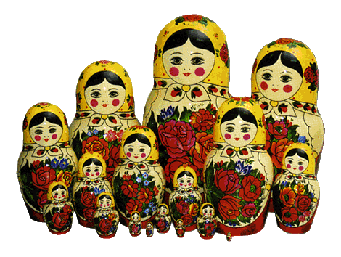
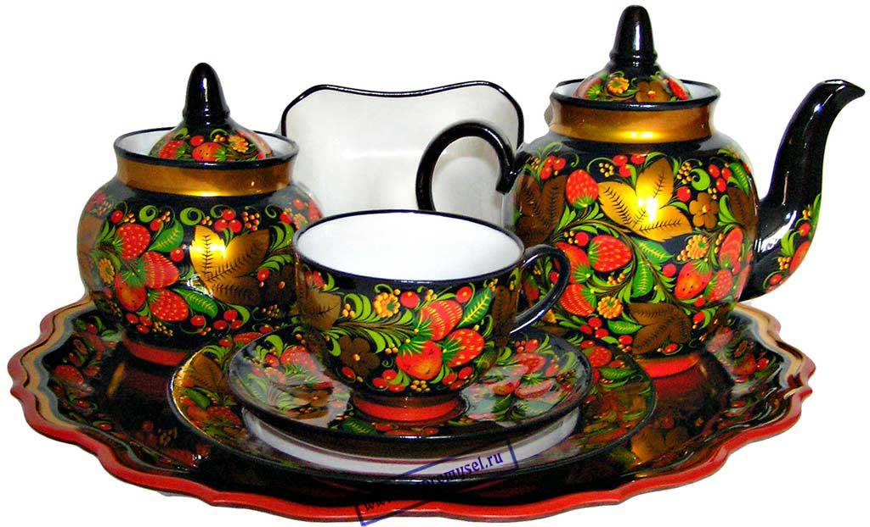
b)

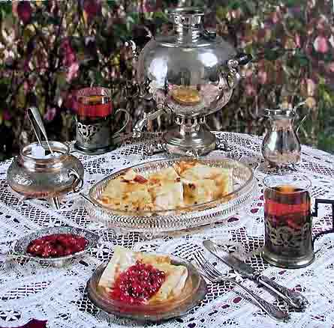
c)

Исаак Левитан
Биографические факты

Isaak Levitan (1860-1900), a Russian artist
- was born in August; had two sisters and a brother
- spent his childhood in a small village of Kibarty
- in 1873 began learning to paint
- had to earn his living after his parents' deaths (mother – 1875, father – 1877)
- showed the poetic beauty of Russian nature in his paintings
- used the best traditions of Russian artists
- watched the countryside, the fields, the woodlands, the meadows
- one of his famous works is "Autumn Day. Sokolniki Park" (1879)
- A. Chekhov called him "Russia's best landscape painter"

Текстовое сопровождение к видеоролику

We want to tell you about one of the most attractive Russian cities, situated on the banks of the picturesque river Volga. Its original name was Tsarizin.
Founded in 1589 as a guarding fortress of the southern borders of Russia, the town was a witness of many historical events.
The Volga-river has always been part of the town’s history. Famous for its rare beauty and unique landscape, the river has become a symbol of the city and one of the most favourite places of its people.
The advantageous geographical position of the city created favourable conditions for its development. Nowadays it is a large industrial, administrative, educative and cultural centre, with the population of over one million citizens. It is the city of unusual beauty, where a lot can be seen and much can be done.
With its wonderful squares, wide streets, and green parks the city looks smart and splendid. There are a great number of museums, exhibitions, modern and historical places of interest there. Its beautiful buildings with interesting architecture make a vivid impression on its visitors. Numerous monuments and memorials can be seen in the streets of the town which is also famous for being a memorial city.
The memory of World War II is deeply felt here. There is a place in the city which is closely connected with the events of the Great Patriotic War and the Stalingrad Battle – it is the glorified Mamayev Hill with its memorial complex “To the Heroes of the Stalingrad Battle”, which appears to be the most attended monument in Russia.
Тест-викторина «Насколько Вы патриотичны?»
Are you proud of your nation? It is fine to be patriotic, but it is not good to be blind to the faults of your nation and to want to be separate and better than all other nations. We are all in this world together! Take this quiz to see how patriotic you are.

1. During the Olympics, you only watch events in which people from your country are performing.  - True  - False | 6. You know all the words to your nation’s national anthem.  - True  - False
2. You have your country’s flag hanging somewhere in your room or home.  - True  - False | 7. You prefer films that are made in your home country, or are in your first language.  - True  - False
3. You have friends and pen friends from other nations.  - True  - False | 8. Your favourite rock star is from your home country.  - True  - False
4. You would never consider living outside your home country (if it were possible).  - True  - False | 9. You know a lot about your nation’s history.  - True  - False
5. If someone criticizes your home nation, you defend it, even if you know that person’s criticisms are valid.  - True  - False | 10. You think your country is the best country in the world.  - True  - False
ANSWERS
- a – 10 b – 5  - a – 10 b – 5  - a – 5 b – 10 | - a – 10 b – 5  - a – 10 b – 5  - a – 10 b – 5 | - a – 10 b – 5  - a – 10 b – 5  - a – 10 b – 5 | - a – 10 b – 5

90 – 100 points: You are very patriotic. It’s good that you like your country, but don’t forget that you can learn things from other nations, and people from other nations, too.
85 – 65 points: You seem to have a healthy amount of patriotism. You like your country, but you appreciate other countries too. It’s important to be able to see the faults of your country and love it at the same time.
60 – 50 points: You are not very patriotic. Are you a citizen of the world, or do you actually dislike your home country? There are good things about any place. Maybe you have forgotten what makes your home special. Don’t take it for granted

