**True or False?**

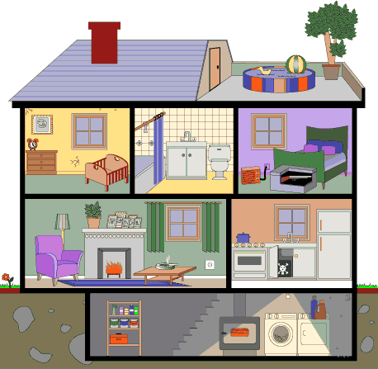

1. The house has two floors.

2. The living room is upstairs. 

3. There is no bathroom in the house.  4. There is a fireplace in the living room. 

5. The bedroom is downstairs. 

6. The walls in the living room are pink. 

7. There is a swimming pool on the roof of the

house. 

8. There are two windows in the living room. 

9. The kitchen is downstairs. 

10. There is no pantry in the house. 