Конспект урока английского языка
«Do you feel like travelling?»

Организационная информация
Тема урока | «Do you feel like travelling?»
Предмет | Английский язык
Класс | 8 класс
УМК (авторы) | Кузовлев В.П., Лапа Н.М. и др., издательство «Просвещение»
Автор урока (ФИО, должность) | Вершинина Лариса Николаевна  учитель английского языка
Образовательное учреждение | Муниципальное общеобразовательное учреждение «Средняя общеобразовательная школа р.п. Ровное Ровенского района Саратовской области»
Адрес образовательного учреждения | Саратовская область, Ровенский район, р.п. Ровное, ул. Свердлова 1.
Контактные данные участника конкурса | e-mail: rovnoe-108@mail.ru  Телефон: 89271308646  Домашний адрес: Саратовская обл., Ровенский район, р.п. Ровное, ул. Октябрьская, д.108
Методическая информация
Тип урока | Комбинированный.
Цели урока | Мотивировать учащихся к ведению диалога по теме урока, обмену мнениями о путешествии, его положительных и отрицательных моментах, вооружить практическими навыками заполнения карты въезда на территорию США, стандартными выражениями в ситуации общения «На таможне»
Задачи урока | - проверить усвоение лексических и грамматических конструкций;  - развивать способности пользоваться полученными знаниями в монологической речи;  - развивать способности пользоваться полученными знаниями при чтении незнакомого текста на тему урока;  - научить дифференцированному употреблению синонимов travel, journey, voyage, trip;  - развивать умения в аудировании.
Знания, умения, навыки и качества, которые актуализируют/ приобретут ученики в ходе урока | - reading for specific information,  - writing skills – to fill in an arrival card  - listening skills  - speaking skills – will be able to tell about advantages and disadvantages of travelling, make up a dialogue “At the customs”
Необходимое оборудование и используемые материалы | - Smartboard/Notebook 10  - Computer connected to the Internet.  - Internet resources  http://www.ldoceonline.com/dictionary/  http://www.eslpartyland.com/quiz/customs1.htm  http://www.englishmedialab.com/higherlevels/travel%20documents/travel%20documents.html

Ход урока

1.Организационный момент. Приветствие.

Teacher: Good morning!
Pupils: Good morning!
Teacher: How are you today?
Pupils: We are fine, thank you. And you?
2.Введение в сюжет урока.
Teacher: I’m fine too. Sit down, please. Boys and girls, today we’ll start our lesson a bit unusually. Look at the whiteboard and try to guess the missing word.

“The world is a book and those who do not … read only a page”.
St. Augustine
(Слайд1)
If you have any doubts this anagram will be helpful for you. Check your guesses. Right you are, the missing word is “travel”.)
(Слайд2. Анаграмма)
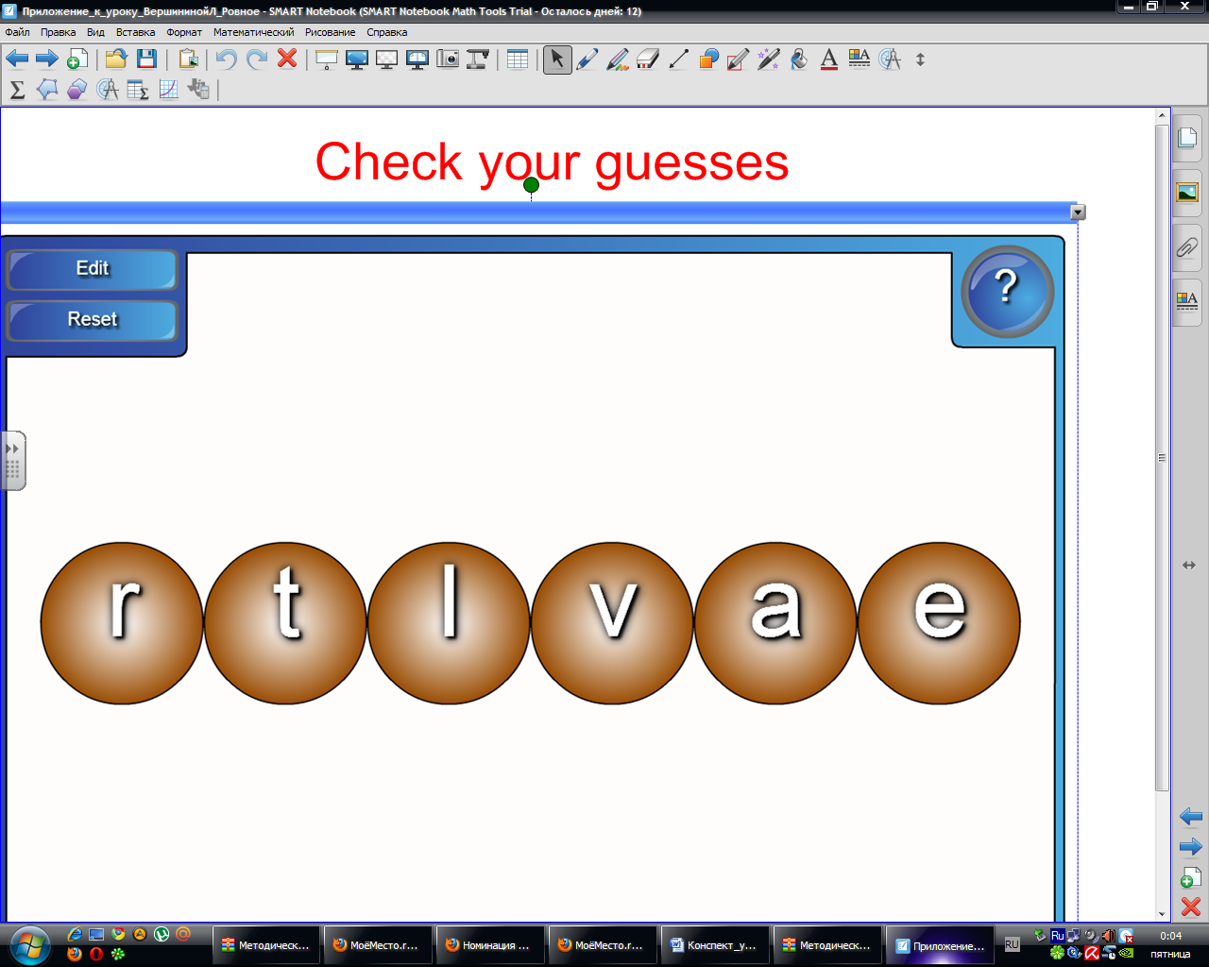
3.Целеполагание.
Right you are. Today we’re going to discuss travelling. Travelling is one of the most favourite activities, isn’t it? We’ll speak about it today you’ll know different opinions about travelling, share your own ideas, listen to the dialogue at the booking-office and try to fill in the arrival card. What do you expect from our lesson for yourselves?
Pupils:
- I want to improve my listening skills.
- As for me, I’d like to learn to fill in some documents needed while travelling. It will be useful.
- I want to practice in oral speech etc.

4.Фонетическая зарядка.
Let’s revise some verbs on the topic:
  - to relax, to meet, to discover, to communicate, to broaden, to try, to improve, to learn, to get to know.

5.Warming up.

Recollect the words connected with the topic Travelling.
Pupils: Ticket, accommodation, hotel, travel agency, travel agent, plane, ship, travelling, sightseeing, guided tour, a coach, hotel reservation

6.Мозговой штурм. Составление кластеров.
Teacher: Now we’ll talk what the word “travelling” means for you. Write down your ideas. Work in groups of four, please!
Примерные ответы учащихся:
- Visiting different countries and places.
- Discovering traditions and customs of different countries.
- Broadening outlook.
- Getting new experience.
- Learning about the history and culture.
- Admiring the beautiful scenery.
- Improving knowledge of the foreign language.
- Meeting different people and making friends.
(Ответы записываются на доску вокруг слова Travelling. Каждая группа записывает ответ пером разного цвета. Для выравнивая написанного учащимися текста используется функция распознавания рукописного текста)

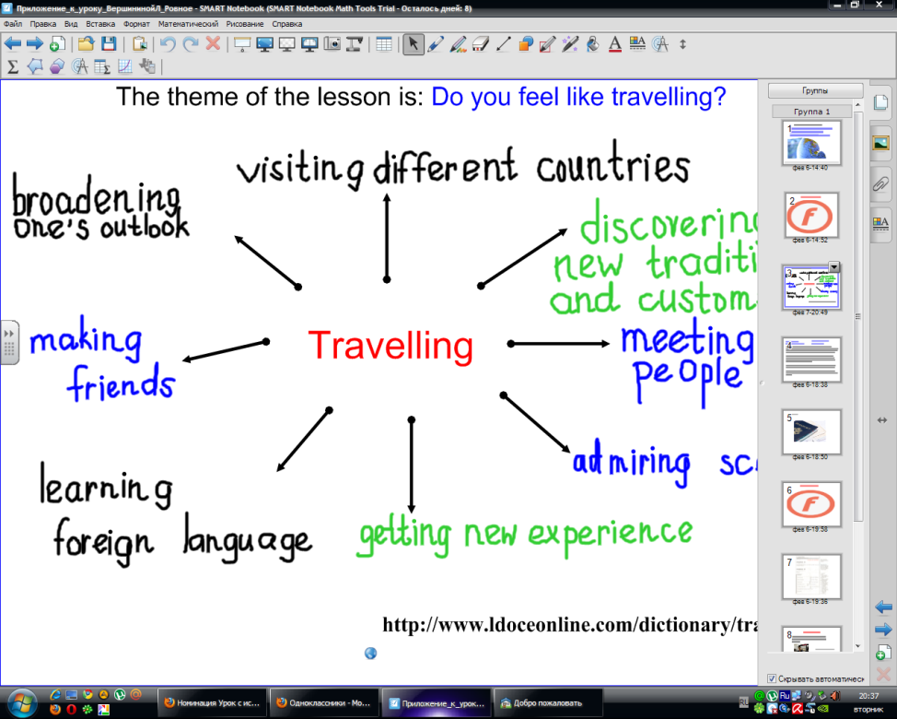

7. Работа с лексикой.

Teacher: OK. Well done. Can you give any synonyms to the word “travel”?
(Travel, journey, trip, voyage)
Find the difference between the words travel, journey, trip and voyage with the help of Longman English Dictionary Online. (Слайд 3)

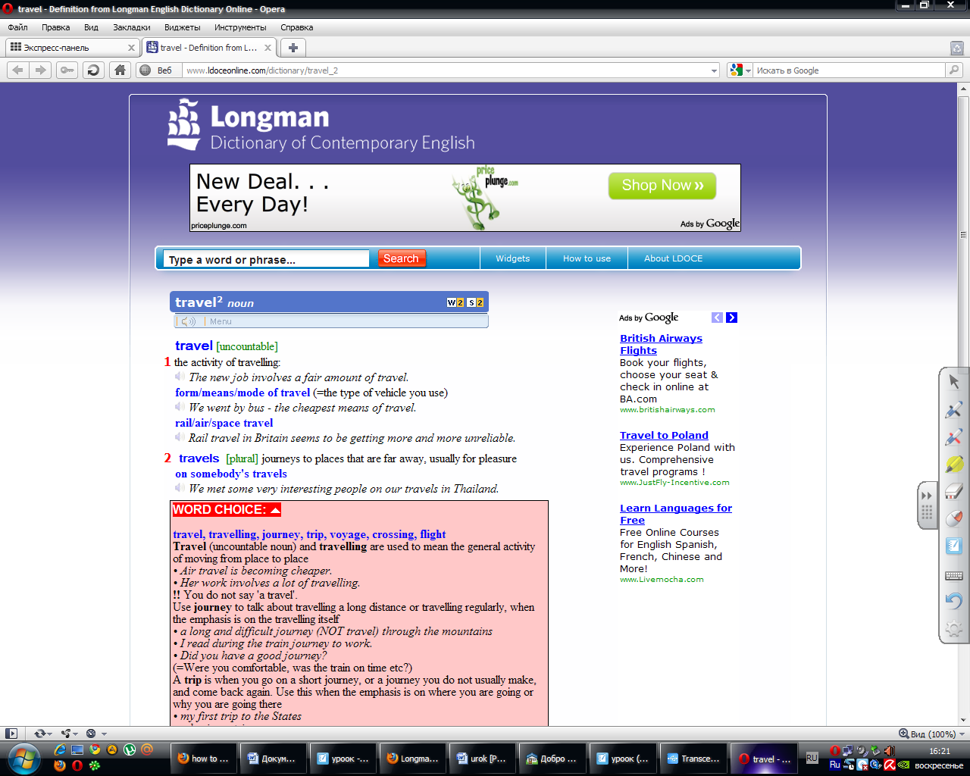
8.Речевая зарядка.

Every year a lot of people from different countries all over the world travel abroad for their holidays.
And what about you?
-Do you like to travel?
-Have you ever been abroad?
-Would you like to visit foreign countries?
-What country would like to visit?

9.Формирование навыков чтения с общим пониманием прочитанного.
There are some character sketches of different people. They express their attitude about travelling. Match the sketches and the people. (Слайд 3)

1.  a businessman | 2.  an experienced traveller | 3.  a professor of History | 4.  a stay-at-home

A. He likes to travel alone or with his students. They travel from curiousity. They like to see the beauty of the world and learn traditions of other countries. They think that travelling is fascinating and enjoyable. It broadens our mind and allows us to understand other people better. | B. He likes to travel alone or with his friends. Usually he travels for pleasure or in search of adventures. When he travels he likes to go sightseeing or explore unknown places. He believes that travelling is exciting and gives us life experience.
C. He doesn`t like to travel at all. He believes that it`s better to stay at home, because travelling is dangerous, troublesome and expensive. | D. Usually he travels alone on business. When he travels he likes to meet new people. He thinks that travelling is useful but sometimes it`s a bit tiring.

10.Этап формирования навыков говорения

Teacher: What documents must one have to make a trip abroad?
(Учащиеся высказывают предположения). Look at the whiteboard and check yourselves. (Слайд 4)
Teacher: So, name the documents you must have to go abroad.

11.Релаксационная пауза. Песня “London bridge is falling down.
(Слайд 5)

12.Заполнение бланков въезда учащимися.
Do you know that when you are on board a stewardess will offer you to fill in the arrival card? Here it is. Try to fill it in with all the necessary information.
(Учащиеся получают и заполняют бланки въезда)
(Слайд 6 для демонстрации карты въезда)
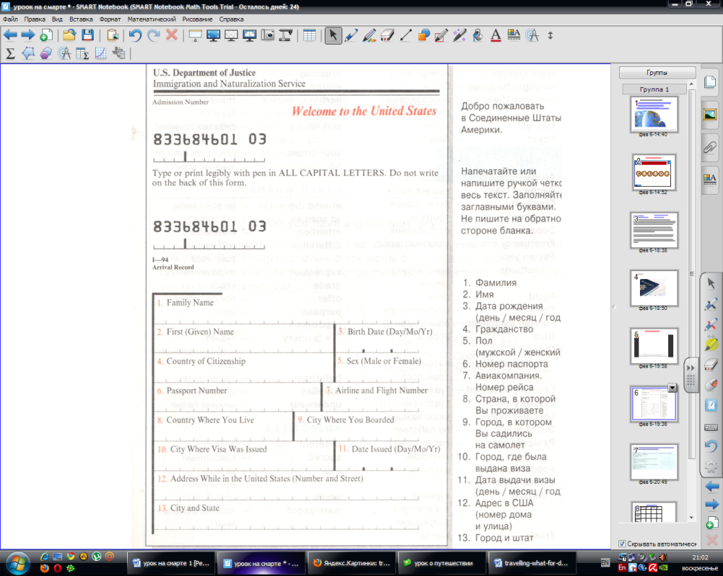

13. Тестирование on-line.
Put the words in a correct order and you will know what questions you may be asked at the customs. (Слайд 7)

14. Составление диалога «At the customs» по составленным в тесте п.13 вопросам таможенного служащего.
- Can I see your passport, please?
-
- How long do you intend to stay in the USA?
-
- What is the purpose of your visit?
-
- Do you have anything to declare?
-
- Enjoy your stay.

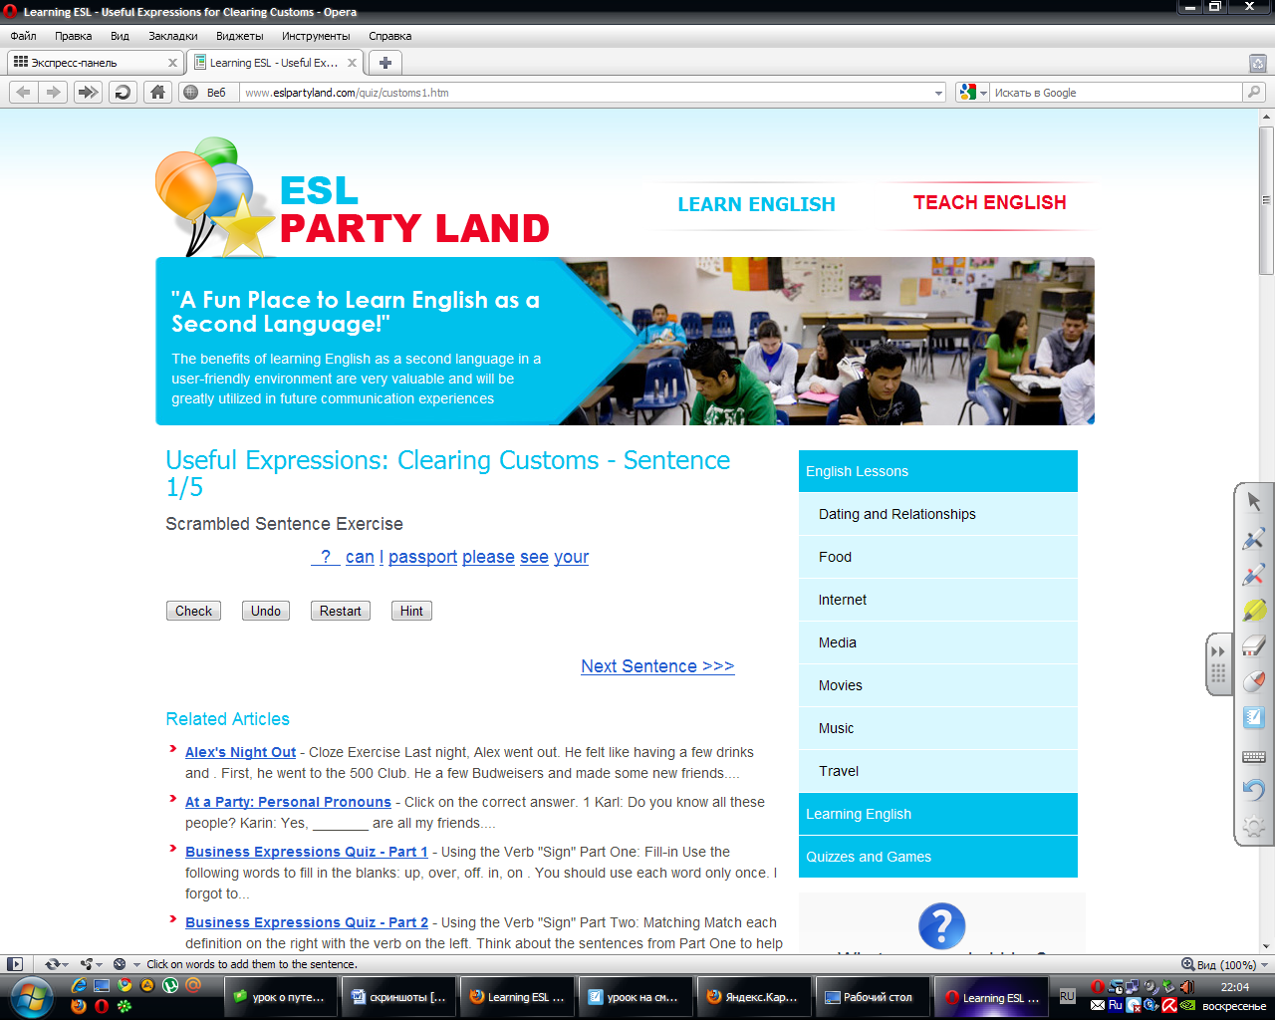
15.Проверка выполнения домашнего задания.
-Have you ever thought that some people don’t like to travel? They prefer to stay at home. They say that traveling has many disadvantages. At home you were to read young people’s opinions about travelling. (Ex.1 p.81). Who is against travelling? What are his/her reasons?

16.Работа в группах. Развитие умений вести дискуссию.
I want you to work in groups to find out all pros and cons of traveling. One group is coach potatoes; another group is fond of travelling. (Учащиеся формируют группы согласно собственным убеждениям).
Now try to prove that it is worth/not worth travelling.

17. Говорение. Выражение личного мнения учащихся о путешествиях.
Do you feel like travelling on your holidays? Why? Why not? You may use the following scheme for your answers:
(Слайд 8)

18. Подведение итогов урока. Рефлексия.

Fill in the control card. (Слайд 9)

I took part in… | Very good | Good | Not good | Bad
Listening to the text
Answering questions
Discussing the problems
Doing tasks
Working in groups
Speaking
My score is _____

- What are your marks?
- The lesson is over.
- Thanks for your work. Good-bye.

