[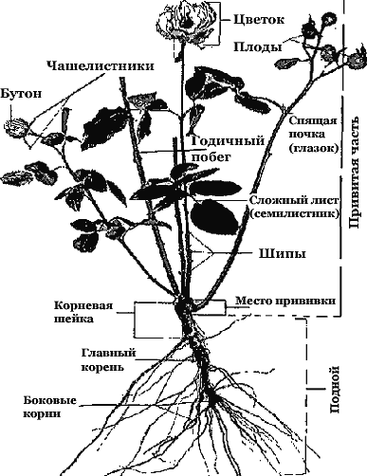](http://www.pushkino.org/ipb/uploads/post-105-1305219674.gif)